# Measuring Forces

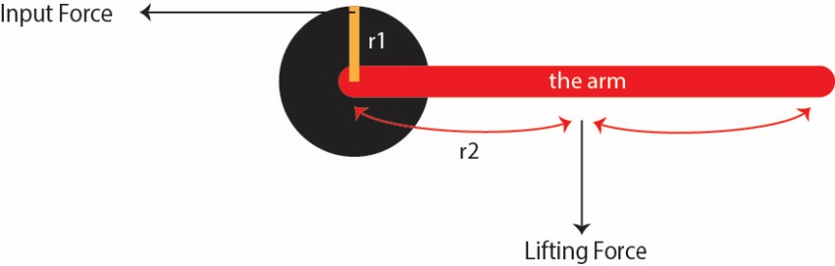

Figure : Force Diagram

Table : Equations Used

|  |  |
| --- | --- |
| Torque ($τ$) | $$F*r*\sin{θ}$$ |
| Lifting force (F) | $$F= \frac{f*r1}{r2}$$ where f is the input force, r1 is the radius of the wheel, and r2 is the length of the arm |

Table : Length of Measured Segments

|  |  |  |
| --- | --- | --- |
| Joint Name | Pulley Radius (m) | Segment Length (m) |
| Elbow | 0.03 | 0.37 |
| Arm | 0.05 | 0.66 |
| Shoulder | 0.06 | 0.86 |

Results

Figure : Results from Arm Test

Table : Summary of Results – Testing the Arm Joint

|  |  |
| --- | --- |
| Test | Input Force Max. (N) |
| No Arm | 212 |
| Lifting Arm (little acceleration) | 444 |
| Lifting Arm (dynamic test) | 753 |
| Overall Max. | 753 |

Figure : Results from Elbow

Table : Summary of Results – Testing the Elbow Joint

|  |  |
| --- | --- |
| Test | Input Force Max. (N) |
| No Forearm | 110 |
| Lifting Forearm (little acceleration) | 160 |
| Lifting Forearm (dynamic test) | 236 |
| Overall Max. | 236 |

Table : Summary of Results – Testing the Shoulder Joint

|  |  |
| --- | --- |
| Test | Input Force Max. (N) |
| No Arm | 147 |
| Lifting Arm (little acceleration) | 330 (joint has a limited range of movement) |
| Lifting Arm (dynamic test) | None |
| Overall Max. | 330 |

Table : Summary of Forces Measured

|  |  |
| --- | --- |
| Joint | Measured Max Force (N) |
| Arm | 753 |
| Elbow | 236 |
| Shoulder | 330 |

# Muscle Specifications based on the Forces above

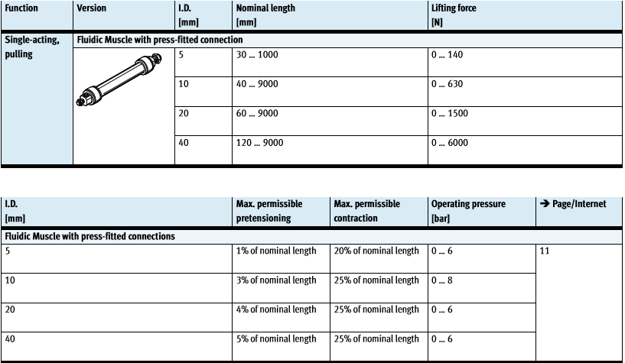

Figure : Festo Air Muscle Specifications

Equations Used

$$pulley radius=test pulley radius* \frac{target force}{current force}$$

$$length of muscle= \frac{1}{contraction}*2*π*pulley radius$$

Muscle Length Specification for the Arm Joint **(target force 753N)**

|  |  |  |
| --- | --- | --- |
| Internal Diameter (mm) | Minimum Pulley Radius (m) | Length of Muscle (m) |
| 5 | 0.25 | 7.853 |
| 10 | 0.05 | 1.256 |
| 20 | 0.0 | Nil |
| 40 | 0.0 | Nil |

Muscle Length Specification for the Elbow Joint **(target force 236N)**

|  |  |  |
| --- | --- | --- |
| Internal Diameter (mm) | Minimum Pulley Radius (m) | Minimum Length of Muscle (m) |
| 5 | 0.03 | 0.942 |
| 10 | 0 | Nil |
| 20 | 0 | Nil |
| 40 | 0 | Nil |

Muscle Length Specification for the Shoulder Joint **(target force 330N)**

|  |  |  |
| --- | --- | --- |
| Internal Diameter (mm) | Minimum Pulley Radius (m) | Minimum Length of Muscle (m) |
| 5 | 0.12 | 3.769 |
| 10 | 0 | Nil |
| 20 | 0 | Nil |
| 40 | 0 | Nil |

Nil – These muscles can provide the forces required, and do not need a pulley

Python Code

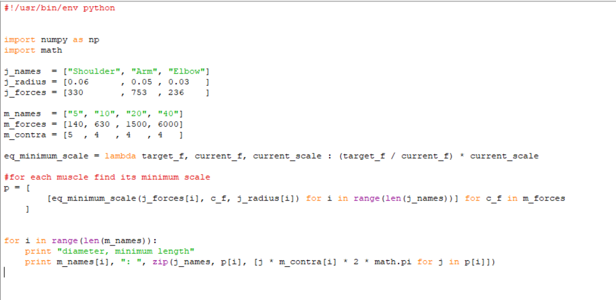

My Recommendation

|  |  |  |  |
| --- | --- | --- | --- |
| Joint Name | Muscle Diameter (mm) | Pulley Radius (m) | Muscle Length (m) |
| Arm | 20 | any | any |
| Elbow | 10 | any | any |
| Shoulder | 10 | any | any |